Chapter 01 :Basic Concepts and Computer Evolution
01*Architecture & Organization:
-Architecture is those attributes visible to the programmer
-Instruction set, number of bits used for data representation, I/O mechanisms, addressin techniques.
-e.g. Is there a multiply instruction?
-Organization is how features are implemented
-Control signals, interfaces, memory technology.
-e.g. Is there a hardware multiply unit or is it done by repeated addition?
-All Intel x86 family share the same basic architecture
-The IBM System/370 family share the same basic architecture
-This gives code compatibility
-At least backwards
-Organization differs between different versions

02*Structure and Function:
Structure:
-The way in which components relate to each other
-Function
-The operation of individual components as part of the structure

Function:
-There are four basic functions that a computer can perform:
-Data processing
-Data may take a wide variety of forms and the range of processing requirements is broad
-Data storage
-Short-term
-Long-term
-Data movement
-Input-output (I/O) - when data are received from or delivered to a device (peripheral) that is directly connected to the computer
-Data communications – when data are moved over longer distances, to or from a remote device

Control:
A control unit manages the computer’s resources and orchestrates the performance of its functional parts in response

03*There are four main structural components of the computer:
.CPU – controls the operation of the computer and performs its data processing functions
.Main Memory – stores data
.I/O – moves data between the computer and its external environment
.System Interconnection – some mechanism that provides for communication among CPU, main memory, and I/O

04*CPU major structural component:
.Control Unit:
-Controls the operation of the CPU and hence the computer
-Arithmetic and Logic Unit (ALU)
-Performs the computer’s data processing function

.Registers:
-Provide storage internal to the CPU

.CPU Interconnection:
-Some mechanism that provides for communication among the control unit, ALU, and registers

05*Multicore Computer Structure:
.Central processing unit (CPU):
-Portion of the computer that fetches and executes instructions
-Consists of an ALU, a control unit, and registers
-Referred to as a processor in a system with a single processing unit

.Core:
-An individual processing unit on a processor chip
-May be equivalent in functionality to a CPU on a single-CPU system
-Specialized processing units are also referred to as cores

.Processor:
-A physical piece of silicon containing one or more cores
-Is the computer component that interprets and executes instructions
-Referred to as a multicore processor if it contains multiple cores

06*Cache Memory:
-Multiple layers of memory between the processor and main memory
-Is smaller and faster than main memory
-Used to speed up memory access by placing in the cache data from main memory that is likely to be used in the near future
-A greater performance improvement may be obtained by using multiple levels of cache, with level 1 (L1) closest to the core and additional levels (L2, L3, etc.) progressively farther from the core
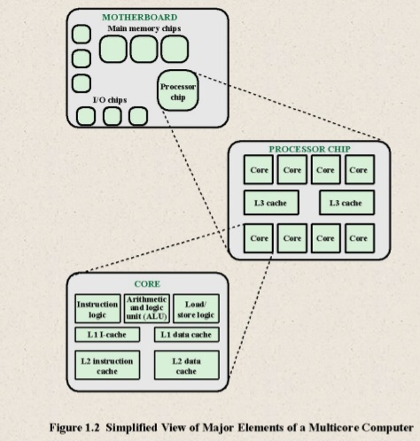
07*History of Computers:
.First Generation: Vacuum Tubes:
-Vacuum tubes were used for digital logic elements and memory
-IAS computer
-Fundamental design approach was the stored program concept
-Attributed to the mathematician John von Neumann
-First publication of the idea was in 1945 for the EDVAC
-Design began at the Princeton Institute for Advanced Studies
-Completed in 1952
-Prototype of all subsequent general-purpose computers

•A main memory, which stores both data and instructions
•An arithmetic and logic unit (ALU) capable of operating on binary data
•A control unit, which interprets the instructions in memory and causes them to be executed
•Input/output (I/O) equipment operated by the control unit
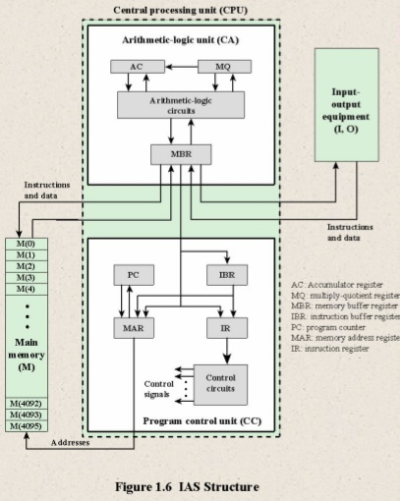

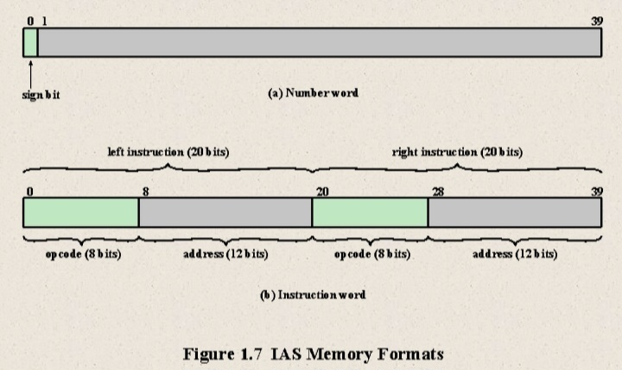

08*Registers:
Memory buffer register (MBR):
.Contains a word to be stored in memory or sent to the I/O unit
.Or is used to receive a word from memory or from the I/O unit

Memory address register (MAR):
.Specifies the address in memory of the word to be written from or read into the MBR

Instruction register (IR):
.Contains the 8-bit opcode instruction being executed

Instruction buffer register (IBR):
.Employed to temporarily hold the right-hand instruction from a word in memory

Program counter (PC):
.Contains the address of the next instruction pair to be fetched from memory

Accumulator (AC) and multiplier quotient (MQ):
.Employed to temporarily hold operands and results of ALU operation

09*History of Computers:
Second Generation: Transistors
-Smaller
-Cheaper
-Dissipates less heat than a vacuum tube
-Is a solid state device made from silicon
-Was invented at Bell Labs in 1947
-It was not until the late 1950’s that fully transistorized computers were commercially available

Second Generation Computers:
.Introduced:
-More complex arithmetic and logic units and control units
-The use of high-level programming languages
-Provision of system software which provided the ability to:
-Load programs
-Move data to peripherals
-Libraries perform common computations
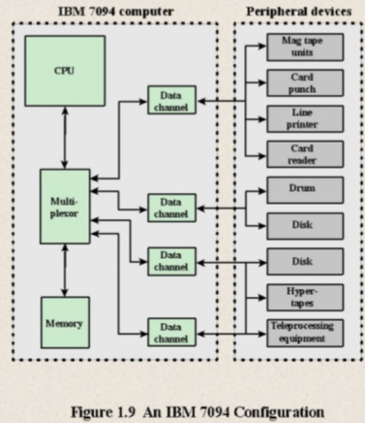

Discrete component:
-Single, self-contained transistor
-Manufactured separately, packaged in their own containers, and soldered or wired together onto masonite-like circuit boards
-Manufacturing process was expensive and cumbersome
-The two most important members of the third generation were the IBM System/360 and the DEC PDP-8

10*Moore’s Law:
-Gordon Moore – co-founder of Intel
-Observed number of transistors that could be put on a single chip was doubling every year
-Since 1970’s development has slowed a little
-Number of transistors doubles every 18 months

.Consequences of Moore’s law:
-The cost of computer logic and memory circuitry has fallen at a dramatic rate
-The electrical path length is shortened, increasing operating speed
-Computer becomes smaller and is more convenient to use in a variety of environments
-Reduction in power and cooling requirements
-Fewer interchip connections: increases reliability

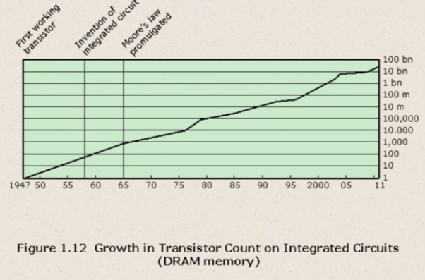

11*IBM System/360:
-Announced in 1964
-Product line was incompatible with older IBM machines
-Was the success of the decade and cemented IBM as the overwhelmingly dominant computer vendor
-The architecture remains to this day the architecture of IBM’s mainframe computers
-Was the industry’s first planned family of computers
-Models were compatible in the sense that a program written for one model should be capable of being executed by another model in the series

Family Characteristics:

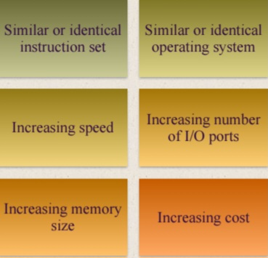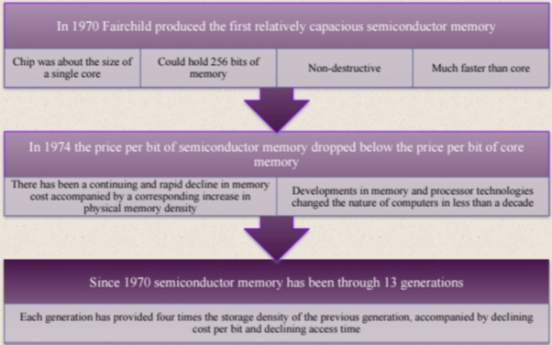

Chapter 02 : Performance Issues
01*Designing for Performance:
-The cost of computer systems continues to drop dramatically, while the performance and capacity of those systems continue to rise equally dramatically
-Today’s laptops have the computing power of an IBM mainframe from 10 or 15 years ago
-Processors are so inexpensive that we now have microprocessors we throw away

-Desktop applications that require the great power of today’s microprocessor-based systems include:
.Image processing
.Three-dimensional rendering
.Speech recognition
.Videoconferencing
.Multimedia authoring
.Voice and video annotation of files
.Simulation modeling
-Businesses are relying on increasingly powerful servers to handle transaction and database processing and to support massive client/server networks that have replaced the huge mainframe computer centers of yesteryear
-Cloud service providers use massive high-performance banks of servers to satisfy high-volume, high-transaction-rate applications for a broad spectrum of clients

Solution: Performance
Balance :
Increase the number of bits that are retrieved at one time by making
DRAMs “wider” rather than “deeper” and by using wide bus data paths
Change the DRAM interface to make it more efficient by including a cache or other buffering scheme on the DRAM chip
Reduce the frequency of memory access by incorporating increasingly complex and efficient cache structures between the processor and main memory
Increase the interconnect bandwidth between processors and memory by using higher speed buses
and a hierarchy of buses to buffer and structure data flow
-Adjust the organization and architecture to compensate for the mismatch among the capabilities of the various components
-Architectural examples include:

I/O Devices:
Peripherals with intensive I/O demands
-Large data throughput demands
-Processors can handle this
-Problem moving data

02*Improvements in Chip:
Organization and Architecture:
-Increase hardware speed of processor
-Fundamentally due to shrinking logic gate size
-More gates, packed more tightly, increasing clock rate
-Propagation time for signals reduced
-Increase size and speed of caches
-Dedicating part of processor chip
-Cache access times drop significantly
-Change processor organization and architecture
-Increase effective speed of instruction execution
-Parallelism

03*Problems with Clock Speed and Logic Density:
.Power:
-Power density increases with density of logic and clock speed
-Dissipating heat
-RC-Resistive-capacitive delay
-Speed at which electrons flow limited by resistance and capacitance of metal wires connecting them
-Delay increases as the RC product increases
-As components on the chip decrease in size, the wire interconnects become thinner, increasing resistance
-Also, the wires are closer together, increasing capacitance
-Memory latency
-Memory speeds lag processor speeds
Solution: More emphasis on organizational and architectural approaches

.Increased Cache Capacity:
-Typically two or three levels of cache between processor and main memory
-Chip density increased
-More cache memory on chip
-Faster cache access
-Pentium chip devoted about 10% of chip area to cache
-Pentium 4 devotes about 50%

04*More Complex Execution Logic:
-Enable parallel execution of instructions
-Pipeline works like assembly line
-The execution of an instruction involves multiple stages of operation (fetch the instruction , decode , fetch operand , perform calculation …)
-Pipelining enables a processor to work simultaneously on multiple instructions by performing a different phase for each of the multiple instructions at the same time.
-Superscalar allows multiple pipelines within single processor
-Instructions that do not depend on one another can be executed in parallel

05*Diminishing Returns:
-Internal organization of processors complex
-Can get a great deal of parallelism
-Further significant increases likely to be relatively modest
-Benefits from cache are reaching limit
-Increasing clock rate runs into power dissipation problem
-Some fundamental physical limits are being reached

06*Multicore:
-The use of multiple processors on the same chip provides the potential to increase performance without increasing the clock rate
-Strategy is to use two simpler processors on the chip rather than one more complex processor
-With two processors larger caches are justified
-As caches became larger it made performance sense to create two and then three levels of cache on a chip

07*Many Integrated Core (MIC) and Graphics Processing Unit (GPU):
MIC:
-Leap in performance as well as the challenges in developing software to exploit such a large number of cores
-The multicore and MIC strategy involves a homogeneous collection of general purpose processors on a single chip

GPU:
-Core designed to perform parallel operations on graphics data
-Traditionally found on a plug-in graphics card, it is used to encode and render 2D and 3D graphics as well as process video
-Used as vector processors for a variety of applications that require repetitive computations

08*Amdahl’s Law:
-was first proposed by Gene Amdahl
-Deals with the potential speedup of a program using multiple processors compared to a single processor
-a speedup in one aspect of the technology or design does not necessarily result in a corresponding improvement in performance
-Illustrates the problems facing industry in the development of multi-core machines
-Software must be adapted to a highly parallel execution environment to exploit the power of parallel processing
-Can be generalized to evaluate and design technical improvement in a computer system
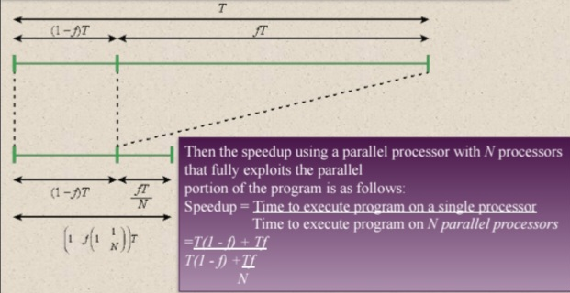
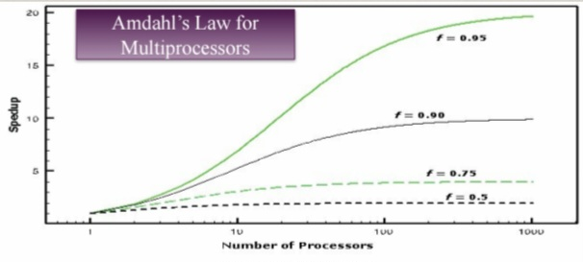
Two important conclusions can be drawn:
1.When f is small, the use of parallel processors has little effect.
2.As N approaches infinity, speedup is bound by 1/(1 – f), so that there are diminishing
returns for using more processors.These conclusions are too pessimistic. For example, a server can maintain multiple threads or multiple tasks to handle multiple clients and execute the threads or tasks in parallel up to the limit of the number of processors. Many database applications involve computations on massive amounts of data that can be split up into multiple parallel tasks.

09*Performance Assessment:
Clock Speed:
-Operations performed by a processor, such as fetching an instruction, decoding the
instruction, performing an arithmetic operation, and so on, are governed by a system clock.
-The speed of a processor is dictated by the pulse frequency produced by the clock, measured in
cycles per second, or Hertz (Hz).
-A 1-GHz processor receives 1 billion pulses per second. The rate of pulses is known as the clock
rate, or clock speed.
-One increment, or pulse, of the clock is referred to as a clock cycle, or a clock tick. The time
between pulses is the cycle time.
-Most instructions on most processors require multiple clock cycles to complete.
-Some instructions may take only a few cycles, while others require dozens.
-When pipelining is used, multiple instructions are being executed simultaneously.
-A straight comparison of clock speeds on different processors does not tell the whole story
about performance.
Instruction Execution Rate:
MIPS = Instruction Count / (Execution Time × 10⁶)
Or
MIPS = Clock Rate / ( CPI × 10⁶)

CPI = CPU Cycles / Instruction Count
Or
CPI = Execution Time × Clock Rate / Instruction Count

10*System Performance Evaluation Corporation (SPEC):
Execution time = CPU Clock Cycles/Clock Rate
Or
Execution Time = # nb of cycles of a Program/ Clock Rate (cycles/Second)
Or
Execution Time = CPU Clock Cycles × Clock Cycle Time

11*SPEC CPU2006:
-Best known SPEC benchmark suite
-Industry standard suite for processor intensive applications
-Appropriate for measuring performance for applications that spend most of their time doing computation rather than I/O
-Consists of 17 floating point programs written in C, C++, and Fortran and 12 integer programs
written in C and C++
-Suite contains over 3 million lines of code
-Fifth generation of processor intensive suites from SPEC

